**BigQuery SQL Analysis**

**By: Arpit Kushwaha**

Average number of items per order - daily, monthly, weekly, state, city, pincode:

1. SELECT
2. EXTRACT(DAY from order_received_timestamp) AS daily,
3. EXTRACT(MONTH from order_received_timestamp) AS monthly,
4. EXTRACT(WEEK from order_received_timestamp) AS weekly,
5. a.state AS state,
6. a.city AS city,
7. f.pincode AS pincode,
8. avg(item_count) as avg_items
9. From  `fractal1a.starschema.fact_daily_orders` f
10. left join `fractal1a.starschema.dim_customer` c
11. on f.customerid = c.customerid
12. left join `fractal1a.starschema.dim_address` a
13. on c.address_id = a.address_id
14. group by
15. daily,
16. monthly,
17. weekly,
18. state,
19. city,
20. pincode

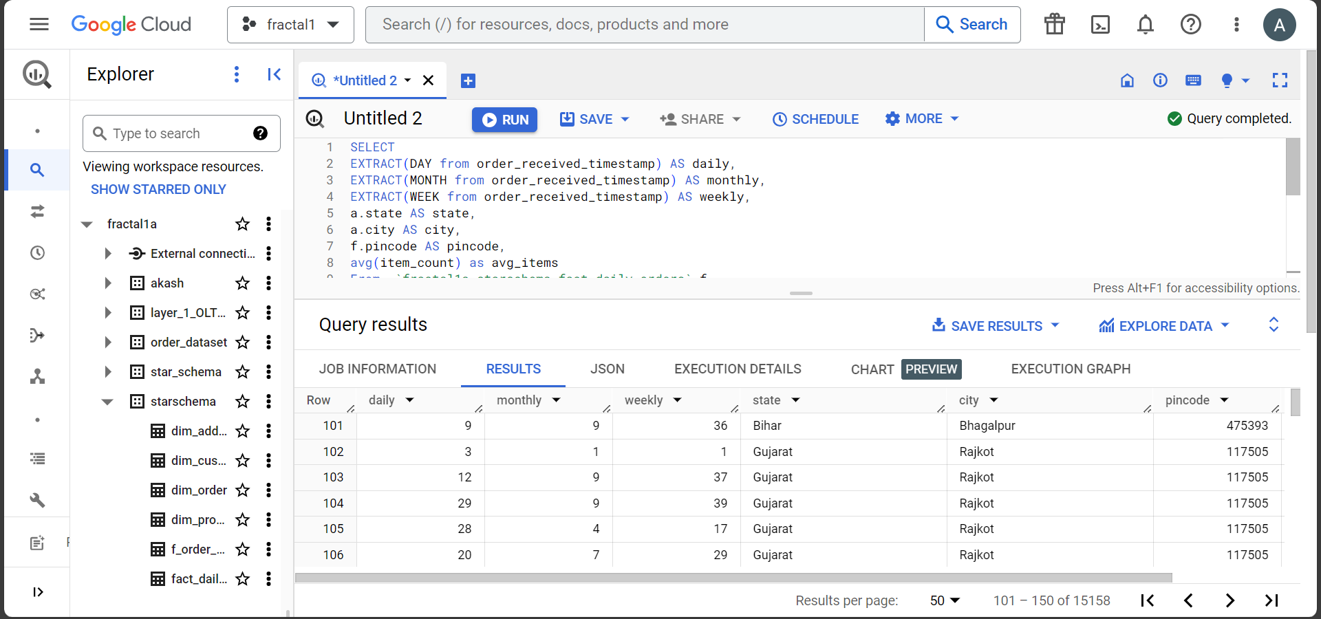

Average amount of sales per order - daily, monthly, weekly, state, city, pincode

1. SELECT
2. EXTRACT(DAY FROM f.order_received_timestamp) AS daily,
3. EXTRACT(MONTH FROM f.order_received_timestamp) AS monthly,
4. EXTRACT(WEEK FROM f.order_received_timestamp) AS weekly,
5. a.state AS state,
6. a.city AS city,
7. f.pincode AS pincode,
8. AVG(order_amount) AS avg_sales
9. From  `fractal1a.starschema.fact_daily_orders` f
10. left join `fractal1a.starschema.dim_customer` c
11. ON f.customerid = c.customerid
12. left join `fractal1a.starschema.dim_address` a
13. ON c.address_id = a.address_id
14. group by
15. daily,
16. monthly,
17. weekly,
18. state,
19. city,
20. pincode

Total number of units sold per day of a product SKU and its monthly trend

1. SELECT
2. p.productname, p.sku,
3. EXTRACT(DAY FROM f.order_delivery_timestamp) AS day,
4. EXTRACT(MONTH FROM f.order_delivery_timestamp) AS month,
5. SUM(quantity) AS units_sold
6. FROM  `fractal1a.starschema.dim_product` p
7. join `fractal1a.starschema.f_order_details` f
8. on p.productid = f.productid
9. group by productname,
10. sku,
11. day,
12. month

Total Order Amount on daily basis, also to be able to split by product and geography

1. SELECT
2. EXTRACT(DATE FROM f.order_received_timestamp) AS daily,
3. o.productid,
4. a.city,
5. sum(order_amount) total_sales
6. FROM `fractal1a.starschema.fact_daily_orders` f
7. join `fractal1a.starschema.f_order_details` o ON f.orderid = o.orderid
8. join `fractal1a.starschema.dim_customer` c ON f.customerid = c.customerid
9. join `fractal1a.starschema.dim_address` a ON c.address_id = a.address_id
10. group by
11. daily,
12. productid,
13. city
14. order by daily

Distribution of orders according to area ( state, city, pincode etc)

1. SELECT
2. a.state,
3. a.city,
4. count(DISTINCT f.orderid) NumberOfOrders
5. FROM `fractal1a.starschema.fact_daily_orders` f
6. join `fractal1a.starschema.dim_customer` c ON f.customerid = c.customerid
7. join `fractal1a.starschema.dim_address` a ON c.address_id = a.address_id
8. group by
9. state,city

Average order amount per customer on daily basis

1. SELECT
2. c.customerid AS id,
3. c.name AS name,
4. EXTRACT(DATE FROM order_received_timestamp) date,
5. ROUND(AVG(order_amount),2) AS OrderAmount
6. FROM `fractal1a.starschema.fact_daily_orders` f
7. left join `fractal1a.starschema.dim_customer` c
8. ON f.customerid = c.customerid
9. group by
10. id, date, name

New Customers on daily basis

1. SELECT
2. START_DATE,
3. COUNT(customerid) AS NewCustomers
4. from `fractal1a.starschema.dim_customer`
5. where customerid in (select customerid from `fractal1a.starschema.dim_customer`
6. group by customerid having count(*)=1)
7. group by start_date

Total count of customers everyday

1. SELECT DISTINCT
2. EXTRACT(DATE FROM order_received_timestamp) Dates,
3. count(*) over (partition by EXTRACT(DATE from order_received_timestamp)) CustomerCounts
4. from `fractal1a.starschema.fact_daily_orders`
5. GROUP BY
6. order_received_timestamp
7. order by Dates

Average time to delivery order. Min and Max time. To be able to slice and dice on hour, weekday, weekend, daily, monthly, geography,

1. SELECT DISTINCT
2. EXTRACT(DATE FROM f.order_delivery_timestamp) DATES,
3. EXTRACT(WEEK FROM f.order_delivery_timestamp) WEEKS,
4. EXTRACT(DAYOFWEEK FROM f.order_delivery_timestamp) WEEKDAYS,
5. EXTRACT(MONTH FROM f.order_delivery_timestamp) MONTHS,
6. a.City,
7. MIN(f.order_delivery_time_seconds) MinDeliveryTime,
8. MAX(f.order_delivery_time_seconds) MaxDeliveryTime,
9. AVG(f.order_delivery_time_seconds) AvgDeliveryTime,
10. FROM `fractal1a.starschema.fact_daily_orders` f
11. join `fractal1a.starschema.dim_customer` c on f.customerid = c.customerid
12. join `fractal1a.starschema.dim_address` a on c.address_id = a.address_id
13. group by
14. DATES,
15. WEEKS,
16. WEEKDAYS,
17. MONTHS,
18. City

Total orders : to be able to slice and dice on hour, weekday, weekend, daily, monthly, geography

1. SELECT DISTINCT
2. EXTRACT(DATE FROM f.order_delivery_timestamp) DATES,
3. EXTRACT(WEEK FROM f.order_delivery_timestamp) WEEKS,
4. EXTRACT(DAYOFWEEK FROM f.order_delivery_timestamp) WEEKDAYS,
5. EXTRACT(MONTH FROM f.order_delivery_timestamp) MONTHS,
6. a.City,
7. COUNT(orderid) NumberOfOrders
8. FROM `fractal1a.starschema.fact_daily_orders` f
9. join `fractal1a.starschema.dim_customer` c on f.customerid = c.customerid
10. join `fractal1a.starschema.dim_address` a on c.address_id = a.address_id
11. group by
12. DATES,
13. WEEKS,
14. WEEKDAYS,
15. MONTHS,
16. City

